Supplementary material

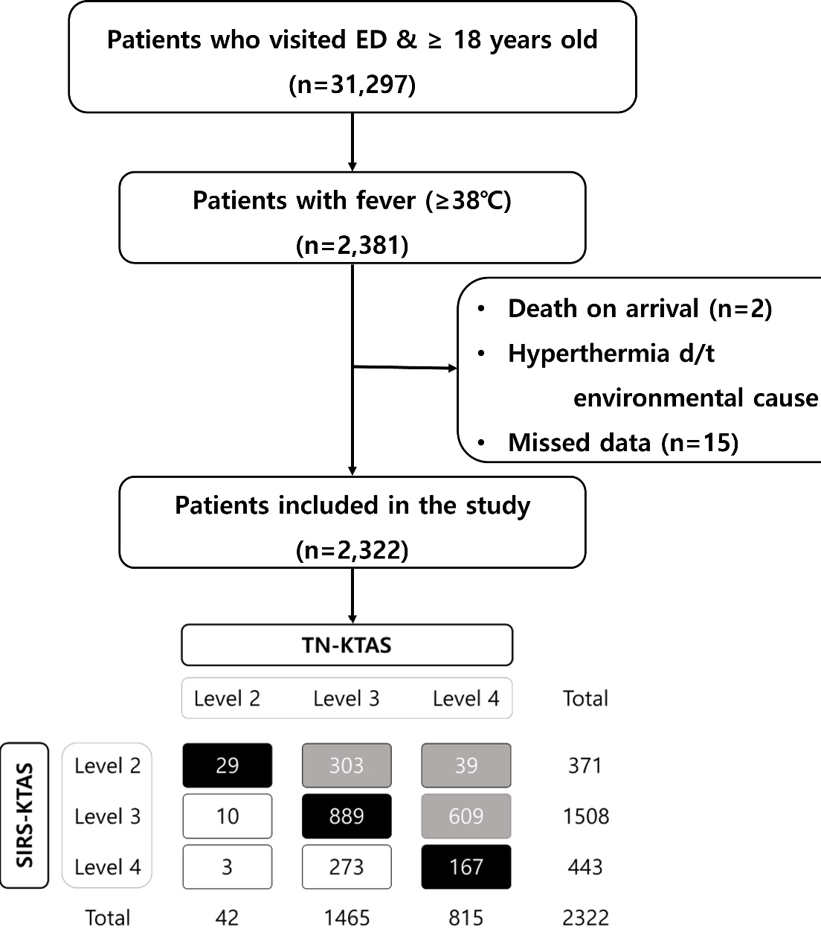
Supplementary Fig. 1. Flow chart of the patient selection. d/t: due to; ED: emergency department; SIRS: systemic inflammatory response syndrome; TN: triage nurse; KTAS: Korean triage and acuity scale.

